**GPS TRACKING SYSTEM**

Our project consists of five main components:

1. TM4C123GH6PM microcontroller
2. RC1602E character LCD
3. Ublox NEO-6m GPS Module
4. HC-05 Bluetooth Module
5. Trajectory Plotter App

**Circuit Schematic**

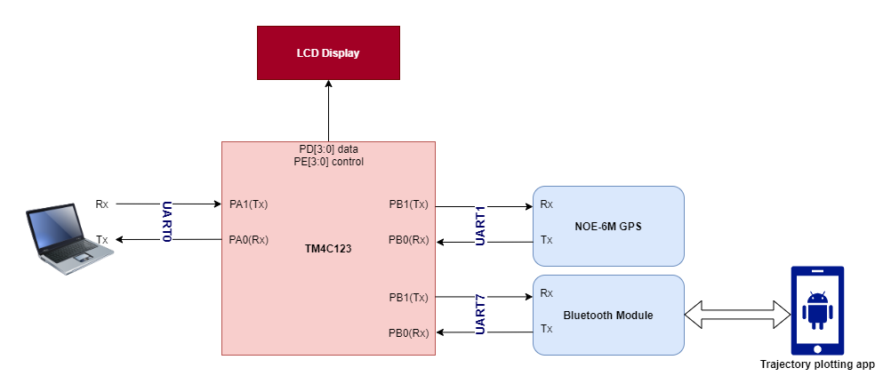

**Pin Configuration**

|  |  |
| --- | --- |
| **Bluetooth module PINS** | **TM4C123 GPIO PINS** |
| +5V | VBUS |
| GND | GND |
| TX | PE4(uart7_rx) |
| RX | PE5(uart7_tx) |

|  |  |
| --- | --- |
| **GPS module PINS** | **TM4C123 GPIO PINS** |
| VCC | VBUS |
| GND | GND |
| TX | PB0(uart0_rx) |
| RX | PB1(uart0_tx) |

|  |  |  |
| --- | --- | --- |
|  | **LCD PINS** | **TM4C123 GPIO PINS** |
| **LCD control** | RS | PE1 |
| RW | PE2 |
| E | PE3 |
| **LCD data** | D7 | PD3 |
| D6 | PD2 |
| D5 | PD1 |
| D4 | PD0 |
| **Power** | VSS | GND |
| VDD | VBUS |
| VO | Potentiometer out |
| A | VBUS |
| K | GND |

**System States**

The system goes through various states throughout its lifetime

**Searching state**

The initial state of the system after it has been powered up.

The GPS searches for nearest satellites to read accurate locations.

It usually takes around 1min and it could last longer if we were in a closed place.

“Searching..” on the lcd and GREEN led indicate we are in the searching state.

**Waiting state**

We enter the Waiting state after the GPS has initialized correctly and we can get readings now.

We should push SW1 to exits this state and start moving.

“GPS Ready” on the lcd indicates we are in the waiting state.

**Reading state**

When we are moving, and the distance is being accumulated.

the distance we have moved would appear on lcd.

BLUE led indicates we are in the reading state.

**Reaching state**

When we reach our destination, which is Total distance of 100m or more.

The readings shall stop, and we shall not increase the distance again.

RED led indicates we have reached our destination.

**Error state**

This state is rare and should not occur in normal operation.

It occurs if the GPS disconnected, or it cannot find enough satellites to get reading from during the reading state.

“Error: GPS Stopped" on the lcd indicates we are in Error state.

A valid reading from the GPS would exit this state and return to Reading state.